Ansible Zero to Hero

Link: https://www.youtube.com/watch?v=wuUiEQ2sI8E&list=PLhW3qG5bs-L_Mjj22rz9e44LI-CUnN2vu

* Ansible is used for configuration management. It is an agentless and passwordless. It doesn’t have master slave concept.
* 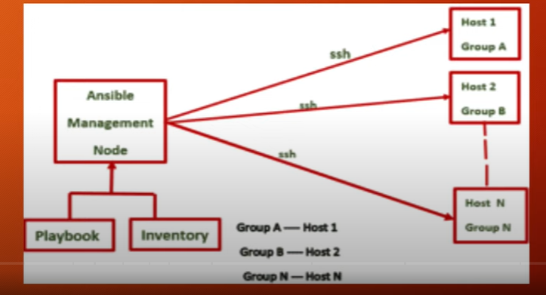It uses ssh protocol to connect to any server.
* Ansible is an open source automation tool.
* You can use Ansible to manage one or many computers at once.
* Can do tasks like configuration management, application deployment, infra setup, software updates, etc.
* The details of the resources to manage (hosts) is kept in a file called Ansible Inventory.
* The instructions to run on hosts are kept in a YAML files called Playbooks.
* For small operations we can use the Ansible Adhoc commands.